UNIVERSITY INSTITUTE OF COMPUTING

PROJECT REPORT
ON
UPI Revolution in India
Internet Ethics
25CAT-105

SUBMITED BY:

Name : Agampal Singh UID : 25BCD10097

Branch :BCA : Data Science Group: B Section:25BCD-2B

Semester : 1st

SUBMITED TO:

Name : Rajat Kapoor D.O.SUBMITION : 05/11/2025

Desigination: Asst. Professor
Sign:____________________

UPI Revolution in India

Title
UPI Revolution in India

Aim / Introduction of the Project
India has witnessed a massive transformation in its financial and economic systems over the past decade, primarily driven by the rapid growth of digital technologies. One of the most significant innovations in this journey has been the Unified Payments Interface (UPI) — a real-time payment system developed by the National Payments Corporation of India (NPCI) and launched by the Reserve Bank of India (RBI) in April 2016. UPI was designed to create a seamless, instant, and interoperable payment infrastructure that allows users to send or receive money directly from their bank accounts using a smartphone.
Before the introduction of UPI, India’s digital payment ecosystem was fragmented, relying heavily on cash transactions and traditional banking methods like NEFT, RTGS, and IMPS. Although digital wallets such as Paytm and Mobikwik had started to gain popularity, they lacked interoperability and required preloaded funds, which limited convenience and scalability. UPI emerged as a unifying layer over existing payment systems, enabling real-time money transfers between any two bank accounts without the need for card details, bank IFSC codes, or wallet recharges.
The introduction of UPI aligned closely with the Government of India’s Digital India initiative, which sought to promote a cashless economy and improve financial inclusion across urban and rural areas. The system’s simplicity — using a Virtual Payment Address (VPA) instead of complex account details — made it accessible even to first-time digital users. Its 24×7 availability, interoperability, and instant settlement capabilities revolutionized the way Indians conducted financial transactions.
Since its inception, UPI has evolved into the backbone of India’s digital payments ecosystem, enabling millions of daily transactions across sectors including retail, e-commerce, utilities, and peer-to-peer transfers. With its integration into popular applications such as Google Pay, PhonePe, Paytm, and BHIM, UPI has empowered consumers, small businesses, and service providers alike. Furthermore, its success has drawn international attention, positioning India as a global leader in real-time payment innovation.
Overall, the UPI revolution represents a paradigm shift in the Indian economy — transforming electronic payments, reducing dependency on cash, and paving the way toward a more inclusive, transparent, and digital financial ecosystem.

Objective
The primary objective of this case study is to analyze the impact of the Unified Payments Interface (UPI) on India’s electronic payment landscape and its significant role in minimizing the country’s dependency on cash transactions. Since its launch in 2016, UPI has been a driving force behind the nation’s transition toward a cashless and digitally empowered economy, and this study aims to explore its multifaceted contributions to that transformation.
A major goal of this research is to examine how UPI simplified digital payments by offering instant, secure, and interoperable transactions across multiple banking platforms. By enabling peer-to-peer (P2P) and peer-to-merchant (P2M) payments, UPI bridged the technological gap between users and financial institutions, thereby enhancing financial inclusion.
This study also seeks to understand the technological infrastructure that powers UPI — including the integration of APIs, the use of IMPS rails, and the application of advanced encryption and authentication mechanisms — which together ensure transaction speed and security.
Another key objective is to assess the economic and behavioral impact of UPI on various stakeholders such as consumers, merchants, financial institutions, and e-commerce platforms. The research highlights how UPI has encouraged the formalization of small-scale transactions, boosted consumer trust in digital platforms, and stimulated the growth of India’s fintech ecosystem.
Finally, the study aims to identify challenges, limitations, and future prospects of UPI as India continues its journey toward becoming a fully digital economy. This includes analyzing scalability issues, cybersecurity challenges, and the potential for UPI to expand globally as a model for digital payment systems.

Overview of E-Commerce Concept Used
The concept of e-commerce revolves around conducting commercial transactions electronically using the internet. It encompasses activities such as buying, selling, and exchanging goods or services online through platforms like Amazon, Flipkart, Myntra, Zomato, and numerous others. In this context, the Unified Payments Interface (UPI) plays a central role by providing a secure, fast, and interoperable payment infrastructure that supports smooth financial exchanges between customers and merchants.
E-commerce platforms thrive on efficient and reliable payment mechanisms, and UPI has become a game-changer in this domain. Unlike debit or credit card payments that involve multiple intermediaries and transaction fees, UPI facilitates direct bank-to-bank transfers in real time. This innovation has eliminated the need for digital wallets and significantly reduced friction in online transactions. By enabling instant fund transfers using only a Virtual Payment Address (VPA) or QR code, UPI has simplified digital commerce for both buyers and sellers.
From a business perspective, UPI enables Business-to-Consumer (B2C) and Consumer-to-Business (C2B) payment models that drive online marketplaces, retail chains, and service-based platforms. For consumers, it ensures convenience, transparency, and trust, while for merchants, it ensures faster settlements, lower transaction costs, and wider customer reach. Additionally, the integration of UPI with government services, utility billers, and subscription-based systems has extended its utility far beyond typical e-commerce boundaries.
Another major contribution of UPI to e-commerce is its role in financial inclusion. Small and medium enterprises (SMEs), street vendors, and local merchants who previously relied on cash now use UPI-enabled QR codes for digital payments. This democratization of payment access has transformed traditional retail models and allowed millions of unbanked or underbanked individuals to participate in the digital economy.
In summary, the UPI framework has not only strengthened India’s e-commerce ecosystem but also bridged the digital divide, making online payments accessible, affordable, and efficient. It continues to power the next wave of e-commerce growth by combining innovation, inclusivity, and interoperability on a national scale.

Working Model / Process Flow
The Unified Payments Interface (UPI) operates as a real-time interbank payment system that allows users to send and receive money instantly using a smartphone. It functions as an overlay network built on top of the Immediate Payment Service (IMPS) infrastructure, managed by the National Payments Corporation of India (NPCI). UPI enables seamless transactions between two bank accounts through mobile applications, removing the need for traditional banking details such as account numbers or IFSC codes.
The process begins when a user installs a UPI-enabled application (such as BHIM, PhonePe, Google Pay, or Paytm) and links it to their existing bank account using the registered mobile number. A Virtual Payment Address (VPA) is then created — for example, username@bankname — which serves as a unique identifier for conducting transactions. This eliminates the need to share sensitive banking details during payments, ensuring privacy and convenience.
When initiating a transaction, the payer enters the recipient’s VPA, the desired amount, and a short description or note. The system then sends a request to the payer’s Payment Service Provider (PSP) bank, which verifies account details and forwards the request to the NPCI switch. NPCI acts as an intermediary that authenticates the transaction and routes it to the payee’s bank. Once both banks confirm fund availability and authorization, the transaction is processed instantly, and the user receives confirmation within seconds.
Security and authentication are maintained through two-factor verification, typically involving the device ID and a UPI PIN created by the user. All transactions are encrypted end-to-end, ensuring data confidentiality and integrity.
Compared to legacy systems like NEFT or RTGS, which operate during limited banking hours, UPI functions 24×7, 365 days a year, providing round-the-clock accessibility. It also supports person-to-person (P2P) and person-to-merchant (P2M) transactions, QR code payments, and recurring mandates through UPI AutoPay.
In essence, UPI’s process flow represents a highly efficient, interoperable, and scalable model that has redefined how money moves in India — enabling digital payments that are instantaneous, secure, and universally accessible.

Benefits and Limitations
The Unified Payments Interface (UPI) has brought about a revolutionary transformation in India’s financial ecosystem by enabling an efficient, secure, and inclusive digital payment infrastructure. Its benefits span across consumers, businesses, and the economy at large, positioning India as a global leader in real-time payment systems. However, despite its remarkable success, UPI also faces certain limitations and challenges that must be acknowledged to ensure its sustained growth and security.
Benefits
- Instant and Real-Time Payments:
UPI enables immediate fund transfers between bank accounts 24×7, including weekends and holidays. This feature has replaced the time delays associated with traditional payment systems like NEFT and RTGS.
- Ease of Use and Accessibility:
Users can make payments using only a Virtual Payment Address (VPA), eliminating the need to remember complex bank details. The interface is user-friendly, making it accessible to people of all age groups and literacy levels.
- Cost Efficiency:
UPI transactions are either free or incur minimal charges, making them more affordable than debit or credit card transactions. This cost advantage has encouraged mass adoption, especially among small merchants.
- Financial Inclusion:
UPI has empowered millions of small businesses and unbanked citizens by providing a direct link to formal banking systems. Even rural vendors and micro-entrepreneurs now accept digital payments through UPI-enabled QR codes.
- Security and Transparency:
UPI follows two-factor authentication and end-to-end encryption, reducing fraud risks. Its integration with RBI and NPCI’s regulatory frameworks ensures accountability and compliance with national financial standards.
- Economic Impact:
The widespread use of UPI has contributed significantly to reducing cash dependency, improving tax compliance, and promoting digital literacy. It has also boosted e-commerce, fintech innovation, and digital entrepreneurship across India.
Limitations
- Technical Glitches and Downtime:
Despite its reliability, UPI occasionally faces transaction failures or delays due to server overloads and connectivity issues, especially during peak transaction hours.
- Cybersecurity Risks:
Increased usage has also attracted phishing, fake app scams, and social engineering attacks. Continuous user education is necessary to minimize such risks.
- Transaction Limits:
RBI and NPCI have set transaction limits to prevent misuse, but this sometimes restricts high-value or business-related payments.
- Dependence on Internet and Smartphones:
UPI’s effectiveness relies heavily on smartphone penetration and stable internet connectivity, which can be a barrier in rural or remote areas.
In summary, while UPI has revolutionized India’s payment landscape by promoting efficiency, inclusion, and transparency, addressing its technological and security challenges will be essential for sustaining its long-term impact and reliability.

- Technology and Payment System Used
The Unified Payments Interface (UPI) operates on a sophisticated technological framework designed by the National Payments Corporation of India (NPCI). Its architecture combines real-time processing, interoperability, and security, allowing multiple banks, fintech companies, and users to interact seamlessly. UPI’s core objective is to enable instant, bank-to-bank money transfers through a mobile-first, API-driven ecosystem.
At the heart of UPI lies the Immediate Payment Service (IMPS) infrastructure, which serves as the backbone for instantaneous interbank fund transfers. Built on this foundation, UPI uses Application Programming Interfaces (APIs) that connect various banks, payment service providers (PSPs), and third-party apps. These APIs facilitate secure communication between different entities and ensure smooth transaction processing across platforms.
Each UPI transaction involves key participants — the payer bank, payee bank, PSP app, and NPCI switch. When a transaction is initiated, encrypted data packets are routed through NPCI’s central switch, verified in real-time, and settled immediately in the user’s bank account. This mechanism ensures zero waiting time and instant confirmation, providing a smooth user experience.
Security is another cornerstone of the UPI system. It employs two-factor authentication (2FA) involving a device ID and a UPI PIN, ensuring that transactions are both authorized and traceable. Moreover, UPI uses end-to-end encryption, tokenization, and multi-layered security protocols to prevent unauthorized access. NPCI continuously monitors transaction data to detect anomalies or fraudulent behavior using AI and machine learning algorithms.
Technological advancements like UPI 2.0, UPI AutoPay, and UPI Lite have further enhanced functionality, enabling recurring payments, small-value offline transactions, and international interoperability. Additionally, QR code-based payments have democratized access, allowing even small vendors to participate in the digital economy.
Overall, the UPI’s robust and scalable technological ecosystem has made it one of the most efficient and secure real-time payment systems in the world, setting a global benchmark for digital finance innovation.

- Risk and Security Measures
While the Unified Payments Interface (UPI) has revolutionized digital transactions in India, it also faces several risks and vulnerabilities inherent in online financial systems. The growing adoption of UPI has attracted cybercriminals who exploit users’ lack of awareness and the evolving nature of digital threats. Therefore, effective security mechanisms and regulatory safeguards have been integrated into UPI’s framework to ensure user protection and maintain trust in the ecosystem.
Risks:
One of the major risks involves phishing attacks, where fraudsters trick users into sharing confidential information such as their UPI PIN or OTP. Additionally, fake or malicious applications disguised as legitimate UPI apps often lead to data theft and unauthorized access. Other risks include transaction failures, server downtime, and issues arising from poor network connectivity, which can cause delays or duplication of payments. Social engineering scams and SIM card cloning have also emerged as significant threats in recent years.
Security Measures:
To mitigate these risks, UPI follows a robust two-factor authentication (2FA) protocol, ensuring that every transaction is verified using both the device credentials and a user-defined UPI PIN. Furthermore, UPI employs end-to-end encryption, making all transmitted data unreadable to unauthorized entities. NPCI and RBI enforce strict cybersecurity compliance guidelines for all participating banks and Payment Service Providers (PSPs).
Advanced AI-based fraud detection systems continuously analyze transaction patterns to identify suspicious activity in real time. Additionally, frequent security audits, application updates, and user awareness campaigns by NPCI and banks play a vital role in safeguarding the ecosystem.
In conclusion, although UPI is not entirely immune to cyber threats, its layered security architecture, regulatory oversight, and proactive user education collectively ensure a secure, reliable, and resilient payment infrastructure for India’s digital economy.

Findings / Analysis
Since its launch in 2016, the Unified Payments Interface (UPI) has achieved unprecedented success in transforming India’s digital payment ecosystem. The findings of this study highlight how UPI has evolved from a government-backed financial innovation into a global benchmark for real-time payments, fostering financial inclusion and digital literacy at an enormous scale.
Growth and Adoption Trends
UPI’s transaction volume has grown exponentially — from 21 million transactions in 2016 to over 12 billion transactions per month by 2025, according to NPCI reports. This phenomenal growth reflects user trust, technological reliability, and the deep penetration of mobile internet across India. As of 2025, UPI supports more than 400 banks and multiple third-party applications, including Google Pay, PhonePe, Paytm, Amazon Pay, and BHIM. Together, these platforms serve hundreds of millions of users, demonstrating how UPI has become the preferred mode of payment across all demographics.
Economic and Social Impact
UPI has played a pivotal role in reducing India’s dependence on cash, particularly after the 2016 demonetization drive. It has digitized millions of small transactions, increasing transparency and reducing the circulation of unaccounted money. Small and medium enterprises (SMEs), street vendors, and rural merchants have benefited immensely from QR code–based payments, enabling cashless operations even in remote areas. This shift has not only boosted financial inclusion but also expanded the formal economy by integrating micro-level transactions into the banking system.
E-commerce and Business Integration
UPI has become the backbone of India’s e-commerce and service economy. Online platforms such as Amazon, Flipkart, Swiggy, Zomato, and utility payment apps rely heavily on UPI for fast, frictionless transactions. The system’s low transaction cost and instant settlement features have improved cash flow for businesses and enhanced the overall user experience. Moreover, UPI’s support for AutoPay and recurring payments has facilitated subscription-based models in OTT and service industries.
International Expansion
UPI’s success has transcended national boundaries. India has begun internationalizing UPI, enabling payments in countries like Singapore, UAE, France, Bhutan, and Nepal. This global adoption signifies the system’s robustness and scalability, establishing India as a leader in fintech innovation.
Overall Findings
In conclusion, UPI’s rise showcases the power of combining government policy, technology, and user-centric design to achieve financial democratization. It has improved payment efficiency, reduced costs, and strengthened economic transparency, firmly positioning India as the world’s fastest-growing digital payments hub.

Conclusion
The Unified Payments Interface (UPI) stands as one of India’s most remarkable technological and financial innovations, symbolizing the nation’s transition toward a cashless and digitally empowered economy. Since its inception in 2016, UPI has revolutionized how individuals and businesses conduct transactions by offering an instant, secure, and interoperable payment platform accessible to all segments of society.
Through its seamless integration with banks, fintech companies, and e-commerce platforms, UPI has successfully reduced dependency on cash, expanded financial inclusion, and enhanced the convenience of digital payments. Its ability to facilitate real-time money transfers without intermediaries has improved efficiency and transparency across the entire economic system. Moreover, UPI’s integration with micro and small enterprises has significantly empowered local businesses, enabling them to compete in the digital marketplace.
Beyond its national impact, UPI has also positioned India as a global leader in fintech innovation, inspiring other nations to replicate its model. By combining government vision, regulatory support, and technological excellence, UPI has achieved what many global payment systems aspire to — a unified, low-cost, and inclusive platform for all.
In conclusion, UPI has not only transformed India’s payment landscape but also set the foundation for a digitally inclusive future, bridging social and economic divides through technology-driven financial empowerment.

10 .Learning Outcomes
From this case study on the UPI Revolution in India, several valuable insights have been gained about the role of technology in transforming financial systems and promoting digital inclusion. The study provided a deep understanding of how Unified Payments Interface (UPI) simplified complex banking processes, making real-time transactions accessible to every segment of society.
It highlighted how effective collaboration between government institutions, technology providers, and financial regulators can drive innovation at a national scale. The research also emphasized the importance of cybersecurity, data protection, and user education in maintaining trust within digital ecosystems.
By examining UPI’s integration with e-commerce, small businesses, and global markets, the study demonstrated how digital payment platforms can boost economic growth and reduce dependency on cash. Overall, this project enhanced analytical, technical, and research skills while reinforcing the importance of financial technology as a tool for inclusive development.

- References
- National Payments Corporation of India. (2024). UPI Product Statistics and Growth Reports. Retrieved from https://www.npci.org.in
- Reserve Bank of India. (2023). Report on Trends and Progress of Banking in India 2022–23. Mumbai: RBI Publications.
- Ministry of Electronics and Information Technology (MeitY). (2023). Digital India Programme Progress Report. Government of India.
- NITI Aayog. (2024). India’s Digital Economy Vision 2025: Transforming Through Fintech and Innovation. New Delhi: NITI Aayog Publications.
- Economic Times. (2024, March). How UPI is Fueling India’s Digital Payment Revolution. Retrieved from https://economictimes.indiatimes.com
- Statista Research Department. (2024). Value and Volume of UPI Transactions in India from 2016 to 2024. Retrieved from https://www.statista.com
- Singh, A., & Gupta, P. (2023). Digital Payment Transformation in India: A Case Study of UPI. Journal of Financial Innovation and Technology, 12(4), 145–158.
- Sharma, R. (2022). Cashless India: The Role of UPI in Financial Inclusion. International Journal of Economics and Business Development, 9(2), 56–67.
- NPCI. (2025). UPI 2.0 and Beyond: Roadmap for the Future of Digital Payments. National Payments Corporation of India White Paper.
- World Bank. (2023). Digital Financial Services in Emerging Economies: India’s UPI Model. Washington, D.C.: World Bank Publications.

11.Screenshots
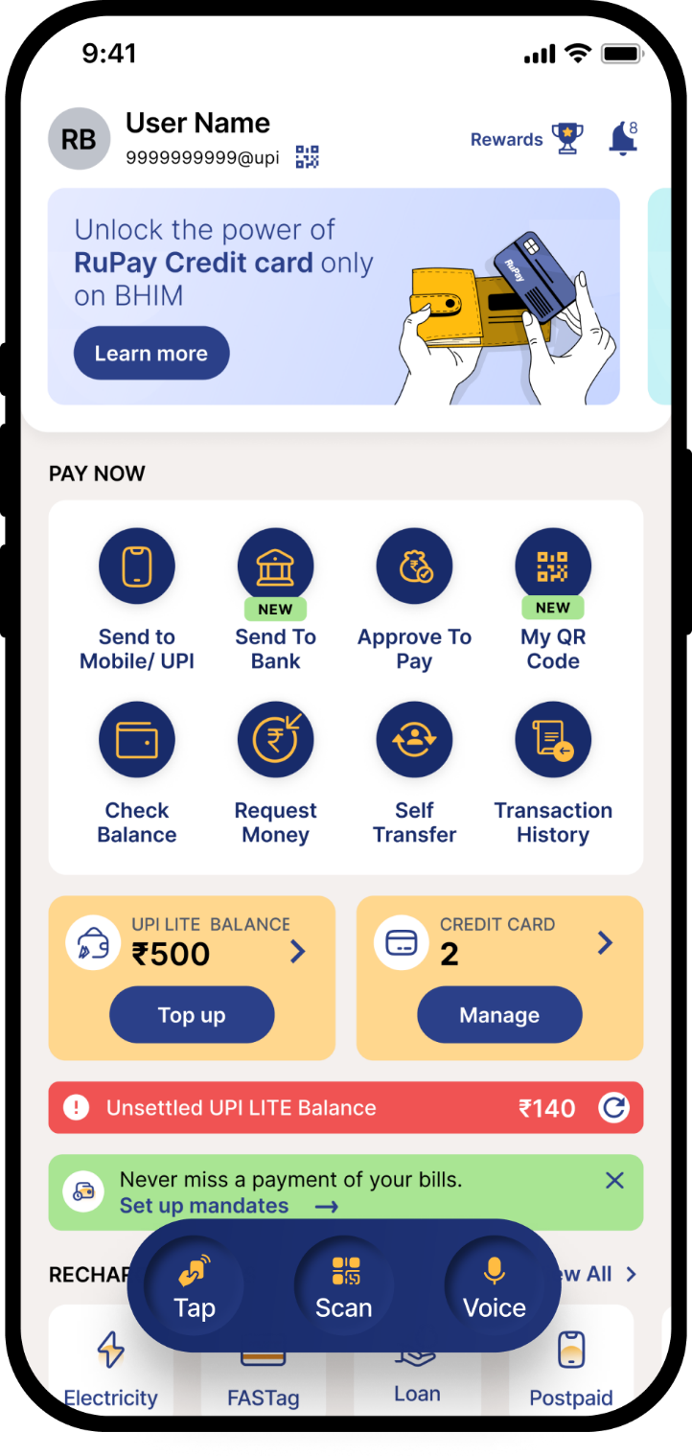 |   Screenshot 2. QR-based payment option from any UPI app.

Screenshot 1. BHIM UPI App home screen showing “Send Money / Request Money.”

Screenshot of GitHub Repositories:

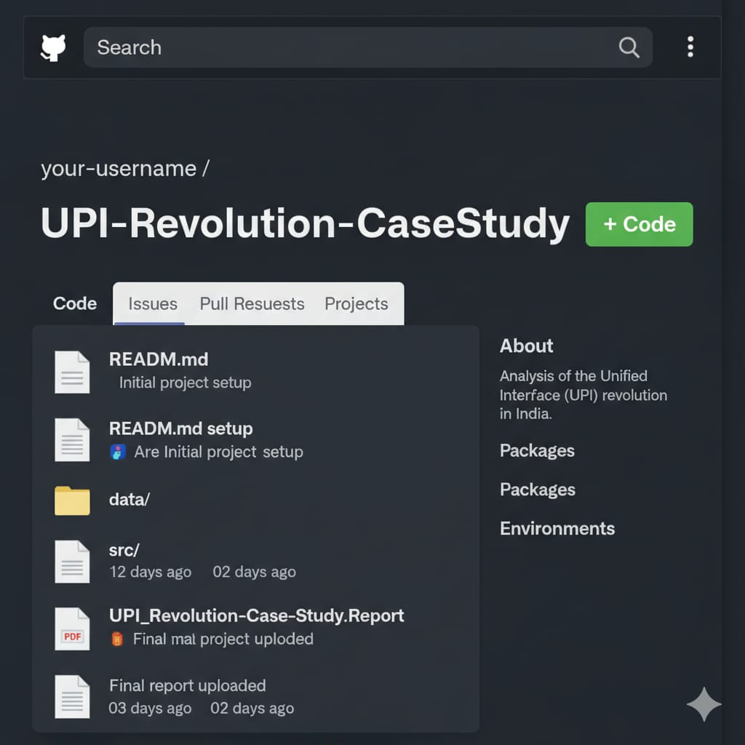



2. Evaluation Grid (To be created as per the SOP and Assessment guidelines by the faculty):
Sr. No. | Parameters | Marks Obtained | Maximum Marks
1. | PROJECT TITLE |  | 2 Marks
2. | CASE STUDY |  | 5 Marks
3. | Github Upload Link |  | 1 Marks
4. | Blog Upload Link |  | 1 Marks
5. | Follow Format |  | 1 Marks
 | TOTAL |  | 10 Marks
 | AVG |  | 6 Marks

Teacher Signature

